English | Dutch | Français | German

Inizio modulo
In order to calculate the correct spoke length a number of measurements must be taken. These measurements must be as precise as possible in order to determine the ideal length.
The details to be measured are given below.
(*) please fill up all fields
  Rim measurements
 | 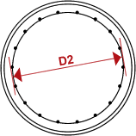 | D2 is the narrowest measured internal diameter of the rim. Please measure across drillings or eyelets.
  D2 | = |  | mm *
 | 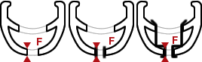
 | F is the thickness of the rim at the nipple holes. If there is an eyelet please measure from the point at which the nipple is supported to the lower edge of the eyelet.
  F | = |  | mm *
  Hub measurements
 | 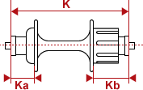
  front wheel
  K | = |  | mm *
  Ka | = |  | mm *
  Kb | = |  | mm *
  rear wheel
  K | = |  | mm *
  Ka | = |  | mm *
  Kb | = |  | mm *
  Flange hole to hole interval
 | 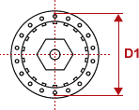 | front wheel  rear wheel
  gear side
  D1 | = |  | mm *
  Non-gear side
  D1 | = |  | mm *
  gear side
  D1 | = |  | mm *
  Non-gear side
  D1 | = |  | mm *
 | Please measure holes on outside edge!
  Extra
front wheel
Number of spokes
  = |  | *
Number of crossings cross connections-gear side
  = |  | *
Number of crossings cross connections-non-gear side
  = |  | *

rear wheel
Number of spokes
  = |  | *
Number of crossings cross connections-gear side
  = |  | *
Number of crossings cross connections-non-gear side
  = |  | *

  Spoke length calculation
 | By means of these measurements we shall calculate the ideal spoke length for you. THE MORE PRECISE THE MEASUREMENTS, THE MORE CORRECT THE SPOKE LENGTH.
 | Terms and conditions
I have read the above conditions and
I agree
I do not agree

  Click here for the results :
Spoke length gear side
  front wheel | rear wheel
    = |  | mm
    mm
Spoke length non-gear side
    = |  | mm
    mm

 | print results

Fine modulo

